Tugas CBIR (Content-Based Image Retrieval)

Pengolahan Citra Digital dan Visi Komputer
Kelas A

Disusun oleh:
Andrew Salim (205150207111048)
Gabriel Winasta Sinisuka (205150201111001)



PROGRAM STUDI TEKNIK INFORMATIKA
JURUSAN TEKNIK INFORMATIKA
FAKULTAS ILMU KOMPUTER
UNIVERSITAS BRAWIJAYA
MALANG
2025

Daftar Isi
Daftar Isi 1
Flowchart sistem 2
Metode 3
Hasil 8
Tabel Precision@5 16
Kesimpulan 21

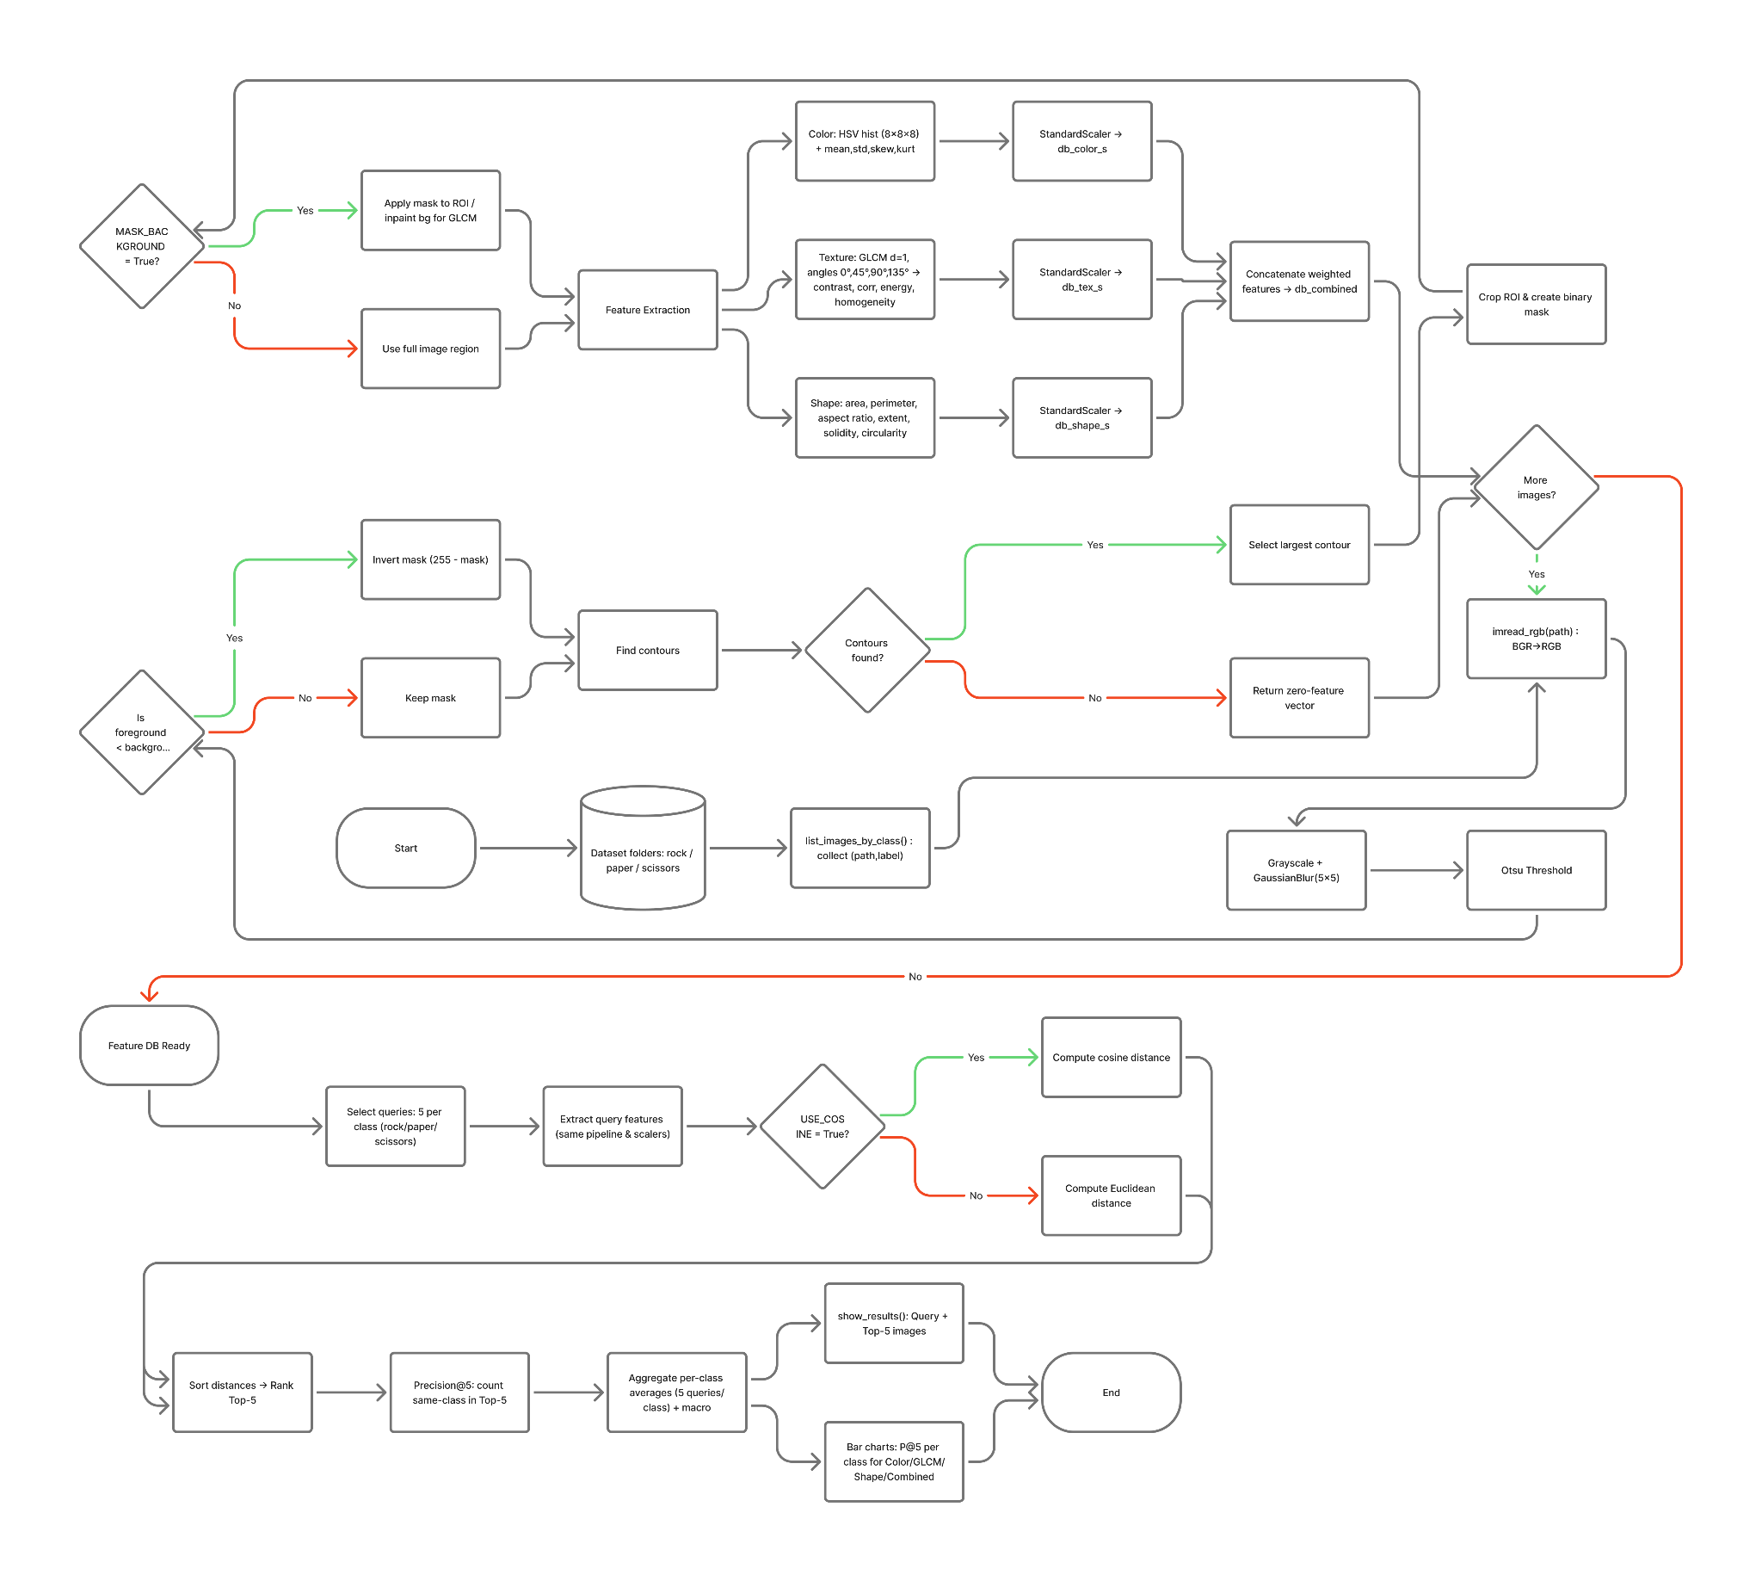
Flowchart sistem

Metode
- Fungsi-Fungsi Pendukung
Fungsi Padding

def padding(img, kernel=5):
pad_img = np.zeros( (img.shape[0]+kernel-1, img.shape[1]+kernel-1 ), dtype='uint8' )

# buat citra noise sebelumnya dengan penambahan padding
real_px = (kernel-1)//2
for i in range( real_px, pad_img.shape[0] - real_px):
for j in range( real_px, pad_img.shape[1] - real_px):
pad_img[i][j] = img[i- real_px][j- real_px ]
return pad_img

Melakukan padding pada citra.

Fungsi Spatial Denoising (Smoothing)

def spatial_denoising(ori_img, k=3, mode='mean'):
# buat salinan citra dan simpan panjang dan lebarnya
img = ori_img.copy()
img = padding(img, kernel=k)
# img = np.zeros( (img.shape[0]+2, img.shape[1]+2 ), dtype='uint8' )
h_idx, w_idx = img.shape[0], img.shape[1]
h_list = list()

# memilih mode filter
if mode == 'mean':
val = 0
elif mode == 'median':
val = list()

# lakukan filtering pada citra
for h in range(h_idx):

w_list = list()
for w in range(w_idx):

# pilih mode
if mode == 'mean':
val = 0
elif mode == 'median':
val = list()

# lakukan filtering dengan kernel (3,3)
for ii in range(k):
is_break = False
for jj in range(k):
try:
# pilih mode
if mode == 'mean':
# hitung rata-rata dari pixel
val += img[ii +h][jj +w] / (k*k)
elif mode == 'median':
# simpan nilai pixel
val.append( img[ii +h][jj +w] )

# jika indexing melebih ukuran citra (index out of bound)
# maka hentikan proses filtering
except:
is_break = True
break
if is_break:
break

# pilih mode
if mode == 'mean':
# bulatkan nilai pixel
val = round(val)
elif mode == 'median':
# urutkan nilai-nilai pixel lalu pilih nilai tengahnya
val.sort()
val = val[ len(val)// 2 ]

# simpan nilai pixel sebagai nilai list
w_list.append( val )
# simpan nilai-nilai pixel sebagai baris
# dengan mengabaikan 2 nilai/kolom terakhir
h_list.append(w_list[:-2])

# simpan citra sebagai numpy array
# dengan mengabaikan 2 nilai/baris terakhir
new_img = np.array(h_list[:-2], dtype='uint8')

#kembailkan nilai
return new_img

Melakukan penghalusan pada citra.

Fungsi Otsu

def otsu(gray):
pixel_number = gray.shape[0] * gray.shape[1]
mean_weigth = 1.0/pixel_number
his, bins = np.histogram(gray, np.array(range(0, 256)))
final_thresh = -1
final_value = -1
for t in bins[1:-1]:
Wb = np.sum(his[:t]) * mean_weigth
Wf = np.sum(his[t:]) * mean_weigth

mub = np.mean(his[:t])
muf = np.mean(his[t:])

value = Wb * Wf * (mub - muf) ** 2

if value > final_value:
final_thresh = t
final_value = value
final_img = gray.copy()
final_img[gray > final_thresh] = 255
final_img[gray < final_thresh] = 0
return final_img
Melakukan binerisasi citra dengan metode otsu.

Fungsi Region of Interest (ROI)

def hand_mask_and_roi(img_rgb):
gray = cv2.cvtColor(img_rgb, cv2.COLOR_RGB2GRAY)
blur = spatial_denoising(gray, k=5, mode='median')
th = otsu(blur)
if (th==255).sum() < (th==0).sum():
th = 255 - th

cnts, _ = cv2.findContours(th, cv2.RETR_EXTERNAL, cv2.CHAIN_APPROX_SIMPLE)
if not cnts:
h, w = th.shape
return np.zeros((h,w), np.uint8), img_rgb, th

c = max(cnts, key=cv2.contourArea)
x, y, w, h = cv2.boundingRect(c)

roi_img = img_rgb[y:y+h, x:x+w].copy()
roi_mask = th[y:y+h, x:x+w].copy()
roi_mask = cv2.erode(roi_mask, np.ones((3,3), np.uint8), iterations=1)

h, w = img_rgb.shape[:2]
roi_img = cv2.resize(roi_img, dsize=(w, h))
roi_mask = cv2.resize(roi_mask, dsize=(w, h))
th = cv2.resize(th, dsize=(w, h))

return roi_mask, roi_img, th
Melakukan masking berdasarkan area dengan menggunakan countour.

- Ekstraksi Fitur Warna

def extract_color_features(img_rgb):
# HSV 3D histogram (8-8-8) Mask contour digunakan tanpa backround
if MASK_BACKGROUND:
mask, roi_img, _ = hand_mask_and_roi(img_rgb)
hsv = cv2.cvtColor(roi_img, cv2.COLOR_RGB2HSV)
hist = cv2.calcHist([hsv], [0,1,2], mask, [8,8,8], [0,180, 0,256, 0,256])
else:
hsv = cv2.cvtColor(img_rgb, cv2.COLOR_RGB2HSV)
hist = cv2.calcHist([hsv], [0,1,2], None, [8,8,8], [0,180, 0,256, 0,256])

#normalisasi histogram
hist = cv2.normalize(hist, hist).flatten()

#aplikasi statistik mean, std, skew, kurt
mean, std = hist.mean(), hist.std() + 1e-12
skew = ((hist-mean)**3).mean() / (std**3)
kurt = ((hist-mean)**4).mean() / (std**4)

return np.concatenate(([mean, std, skew, kurt], hist)).astype("float32")

Melakukan ekstraksi fitur berdasarkan warna HSV.

- Ekstraksi Fitur Tekstur

def extract_texture_features(img_rgb):
# glcm pada roi tangan
if MASK_BACKGROUND:
mask, roi_img, _ = hand_mask_and_roi(img_rgb)

# gray = (rgb2gray(roi_img) * 255).astype('uint8')
gray = cv2.cvtColor(roi_img, cv2.COLOR_RGB2GRAY)

inpaint_mask = (mask == 0).astype('uint8') * 255
gray_filled = cv2.inpaint(gray, inpaint_mask, 3, cv2.INPAINT_TELEA)
base = gray_filled
else:
# base = (rgb2gray(img_rgb) * 255).astype('uint8')
base = cv2.cvtColor(img_rgb, cv2.COLOR_RGB2GRAY)

#aplikasi penggunaan 4 arah berbeda 0, 45, 90, 135
glcm = graycomatrix(base, distances=[1],
angles=[0, np.pi/4, np.pi/2, 3*np.pi/4],
symmetric=True, normed=True)
feats = [graycoprops(glcm, p).mean() for p in ('contrast','correlation','energy','homogeneity')]
return np.array(feats, dtype="float32")

Melakukan ekstraksi fitur berdasarkan tekstur dengan Gray-Level Co-occurrence Matrix (GLCM).

- Ekstraksi Fitur Bentuk

def extract_shape_features(img_rgb):
# Area, perimeter, aspect ratio, extent, solidity, circularity dari contour terbesar
gray = cv2.cvtColor(img_rgb, cv2.COLOR_RGB2GRAY)
blur = spatial_denoising(gray, k=5, mode='median')
th = otsu(blur)

if (th==255).sum() < (th==0).sum():
th = 255 - th

cnts, _ = cv2.findContours(th, cv2.RETR_EXTERNAL, cv2.CHAIN_APPROX_SIMPLE)
if not cnts:
return np.zeros(6, dtype="float32")
c = max(cnts, key=cv2.contourArea)

area = float(cv2.contourArea(c))
peri = float(cv2.arcLength(c, True)) + 1e-8
x,y,w,h = cv2.boundingRect(c)
aspect = float(w) / max(h, 1)
extent = area / max(w*h, 1)
hull = cv2.convexHull(c)
solidity = area / max(cv2.contourArea(hull), 1e-8)
circularity = (4 * math.pi * area) / (peri**2)

return np.array([area, peri, aspect, extent, solidity, circularity], dtype="float32")

Melakukan ekstraksi fitur berdasarkan bentuk dengan countour.

Hasil
- Import Library

import os, glob, json, math, random
import numpy as np
import pandas as pd
import cv2
import matplotlib.pyplot as plt

from skimage.feature import graycomatrix, graycoprops
from sklearn.preprocessing import StandardScaler
from scipy.spatial.distance import cosine, euclidean

- Simpan alamat file dan target dataset sebagai list
DATASET_DIR = "tugas_cbir/Rock-Paper-Scissors-images_archive"
TOP_K = 5
USE_COSINE = False #menggunakan eucleudian
MASK_BACKGROUND = True

WEIGHT_COLOR = 1.0
WEIGHT_TEXTURE = 1.0
WEIGHT_SHAPE = 1.0
MAX_PER_CLASS = 27

def list_images_by_class(root):
items = []
for cls in sorted(os.listdir(root)):
p = os.path.join(root, cls)
if os.path.isdir(p):
for ext in ("*.jpg","*.jpeg","*.png"):
for fp in glob.glob(os.path.join(p, ext)):
items.append((fp, cls))
return items

dataset = list_images_by_class(DATASET_DIR)
assert dataset, f"error path {DATASET_DIR}"

#limit setiap class 27 total 81
if isinstance(MAX_PER_CLASS, int):
kept, count = [], {}
for path, cls in dataset:
if count.get(cls, 0) < MAX_PER_CLASS:
kept.append((path, cls))
count[cls] = count.get(cls, 0) + 1
dataset = kept
print("Class :", count)
else:
print(f"Menggunakan dataset lengkap {len(dataset)} images.")

Output:

Class : {'paper': 27, 'rock': 27, 'scissors': 27}

- Buat database digunakan untuk menyimpan metadata ekstraksi fitur

db_color, db_tex, db_shape, db_meta = [], [], [], []

for path, cls in dataset:
img = imread_rgb(path)
img = cv2.resize(img, dsize=(300, 200))
db_color.append(extract_color_features(img))
db_tex.append(extract_texture_features(img))
db_shape.append(extract_shape_features(img))
db_meta.append((path, cls))

db_color = np.vstack(db_color)
db_tex = np.vstack(db_tex)
db_shape = np.vstack(db_shape)

sc_color = StandardScaler().fit(db_color)
sc_tex = StandardScaler().fit(db_tex)
sc_shape = StandardScaler().fit(db_shape)

db_color_s = sc_color.transform(db_color)
db_tex_s = sc_tex.transform(db_tex)
db_shape_s = sc_shape.transform(db_shape)

db_combined = np.hstack([
WEIGHT_COLOR*db_color_s,
WEIGHT_TEXTURE*db_tex_s,
WEIGHT_SHAPE*db_shape_s
])

print(f"Indexed {len(db_meta)} images.")

Output:

Indexed 81 images.

- Buat fungsi untuk mengurutkan dari nilai terendah hingga tertinggi

def rank(db_feats, q_feat, topk=5, use_cosine=False):
dists = []
for i, f in enumerate(db_feats):
d = cosine(q_feat, f) if use_cosine else euclidean(q_feat, f)
dists.append((i, float(d)))
dists.sort(key=lambda x: x[1])
return dists[:topk]

- Buat fungsi untuk menampilkan citra

def show_results(query_img, results, title="Results"):
plt.figure(figsize=(13,3))
plt.subplot(1, TOP_K+1, 1)
plt.imshow(query_img); plt.axis("off"); plt.title("Query")
for i, (idx, dist) in enumerate(results, start=1):
img = imread_rgb(db_meta[idx][0])
label = db_meta[idx][1]
plt.subplot(1, TOP_K+1, i+1)
plt.imshow(img); plt.axis("off")
plt.title(f"#{i} {label}\n{dist:.2f}")
plt.suptitle(title); plt.tight_layout(); plt.show()

- Buat fungsi Content-Based Image Retrieval (CBIR)

import random
from collections import defaultdict

def queries_per_class(num_per_class=5, feature="combined", class_order=("rock","paper","scissors")):

items_by_class = defaultdict(list)
for path, cls in dataset:
items_by_class[cls].append(path)

def pick_feature_space(which):
if which == "color":
return db_color_s, lambda q: sc_color.transform([extract_color_features(q)])[0]
if which == "glcm":
return db_tex_s, lambda q: sc_tex.transform([extract_texture_features(q)])[0]
if which == "shape":
return db_shape_s, lambda q: sc_shape.transform([extract_shape_features(q)])[0]

# combined
return db_combined, lambda q: np.concatenate([
WEIGHT_COLOR * sc_color.transform([extract_color_features(q)])[0],
WEIGHT_TEXTURE* sc_tex.transform([extract_texture_features(q)])[0],
WEIGHT_SHAPE * sc_shape.transform([extract_shape_features(q)])[0],
])

db_feats, qfeat_fn = pick_feature_space(feature)

total_done = 0
for cls in class_order:
pool = items_by_class.get(cls, [])
if not pool:
print(f" error - '{cls}'. lewatkan.")
continue

if len(pool) >= num_per_class:
picks = random.sample(pool, num_per_class)
else:
picks = [random.choice(pool) for _ in range(num_per_class)]

print(f"\n = {cls.upper()} QUERIES ({len(picks)} images) — fitur: {feature} = ")
for i, q_path in enumerate(picks, start=1):
q_img = imread_rgb(q_path)
q_feat = qfeat_fn(q_img)

results = rank(db_feats, q_feat, TOP_K, USE_COSINE) # 5 terbaik USE_COSINE == FALSE (EUCLIDEAN)

print(f"\n[{cls} #{i}] Query: {os.path.basename(q_path)}")
for rnk, (idx, dist) in enumerate(results, 1):
lab = db_meta[idx][1]
mark = "ok" if lab == cls else "--"
print(f" {rnk}. {os.path.basename(db_meta[idx][0]):18s} | {lab:10s} | {mark} | d={dist:.4f}")

# hasil visualisasi Top-K k (k=5)
show_results(q_img, results, title=f"{cls} query #{i} — Top-{TOP_K} ({feature})")

total_done += 1

print(f"\nDone. Total query: {total_done} (target {len(class_order)*num_per_class}).")

- Kueri CBIR dengan metode warna

queries_per_class(num_per_class=1, feature="color", class_order=("rock","paper","scissors"))
Output:
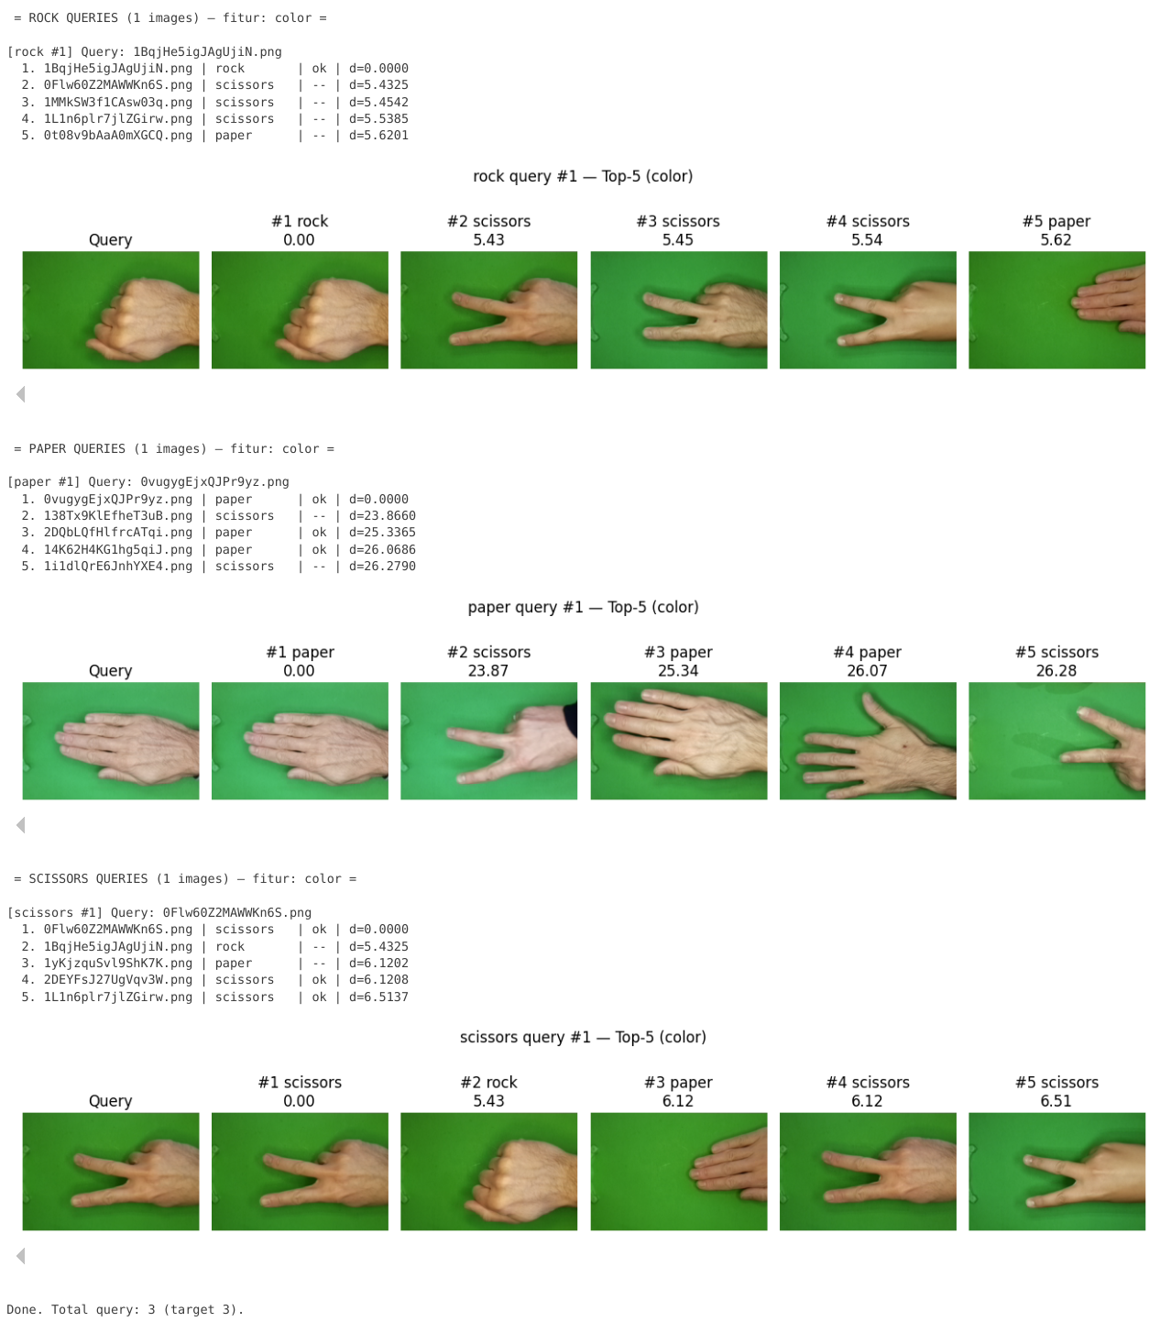
- Kueri CBIR dengan metode tekstur

queries_per_class(num_per_class=1, feature="glcm", class_order=("rock","paper","scissors"))
Output:
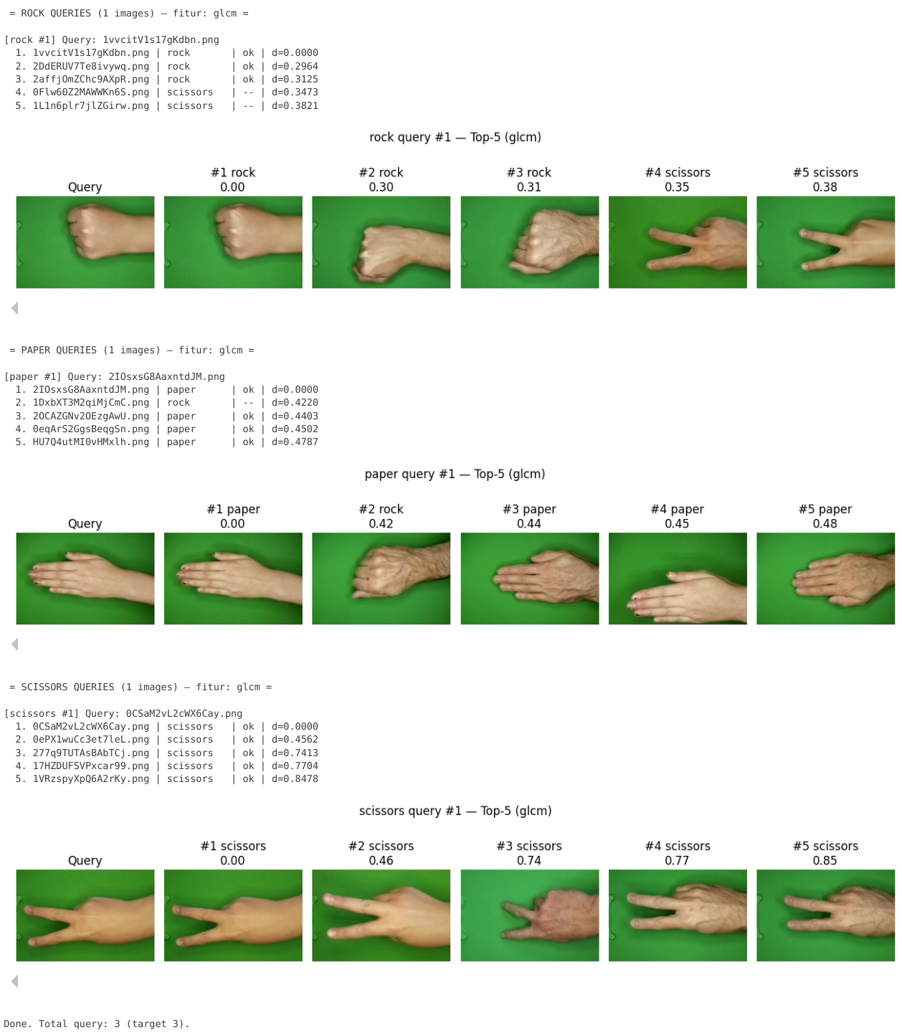
- Kueri CBIR dengan metode bentuk

queries_per_class(num_per_class=1, feature="shape", class_order=("rock","paper","scissors"))
Output:
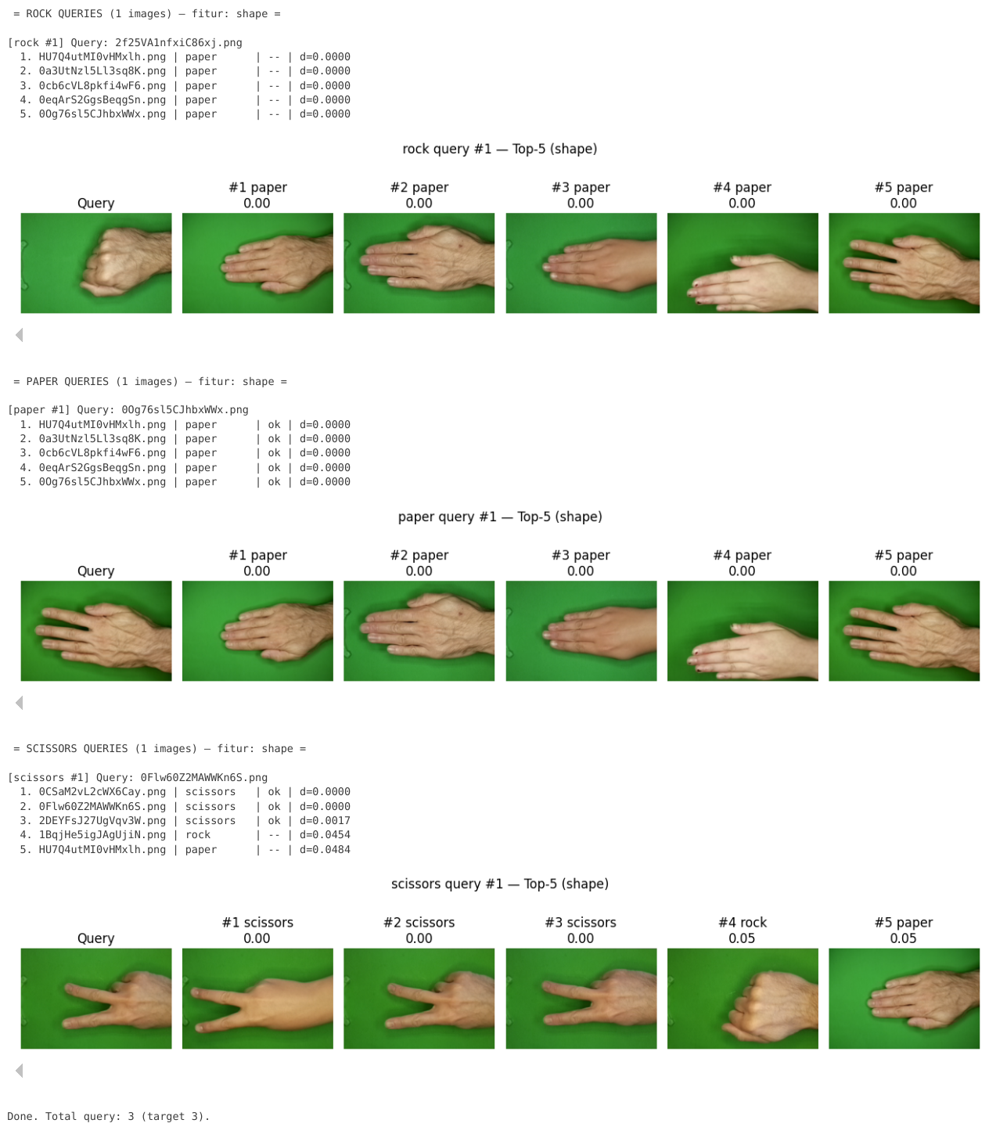
- Kueri CBIR dengan metode gabungan

queries_per_class(num_per_class=1, feature="combined", class_order=("rock","paper","scissors"))
Output:
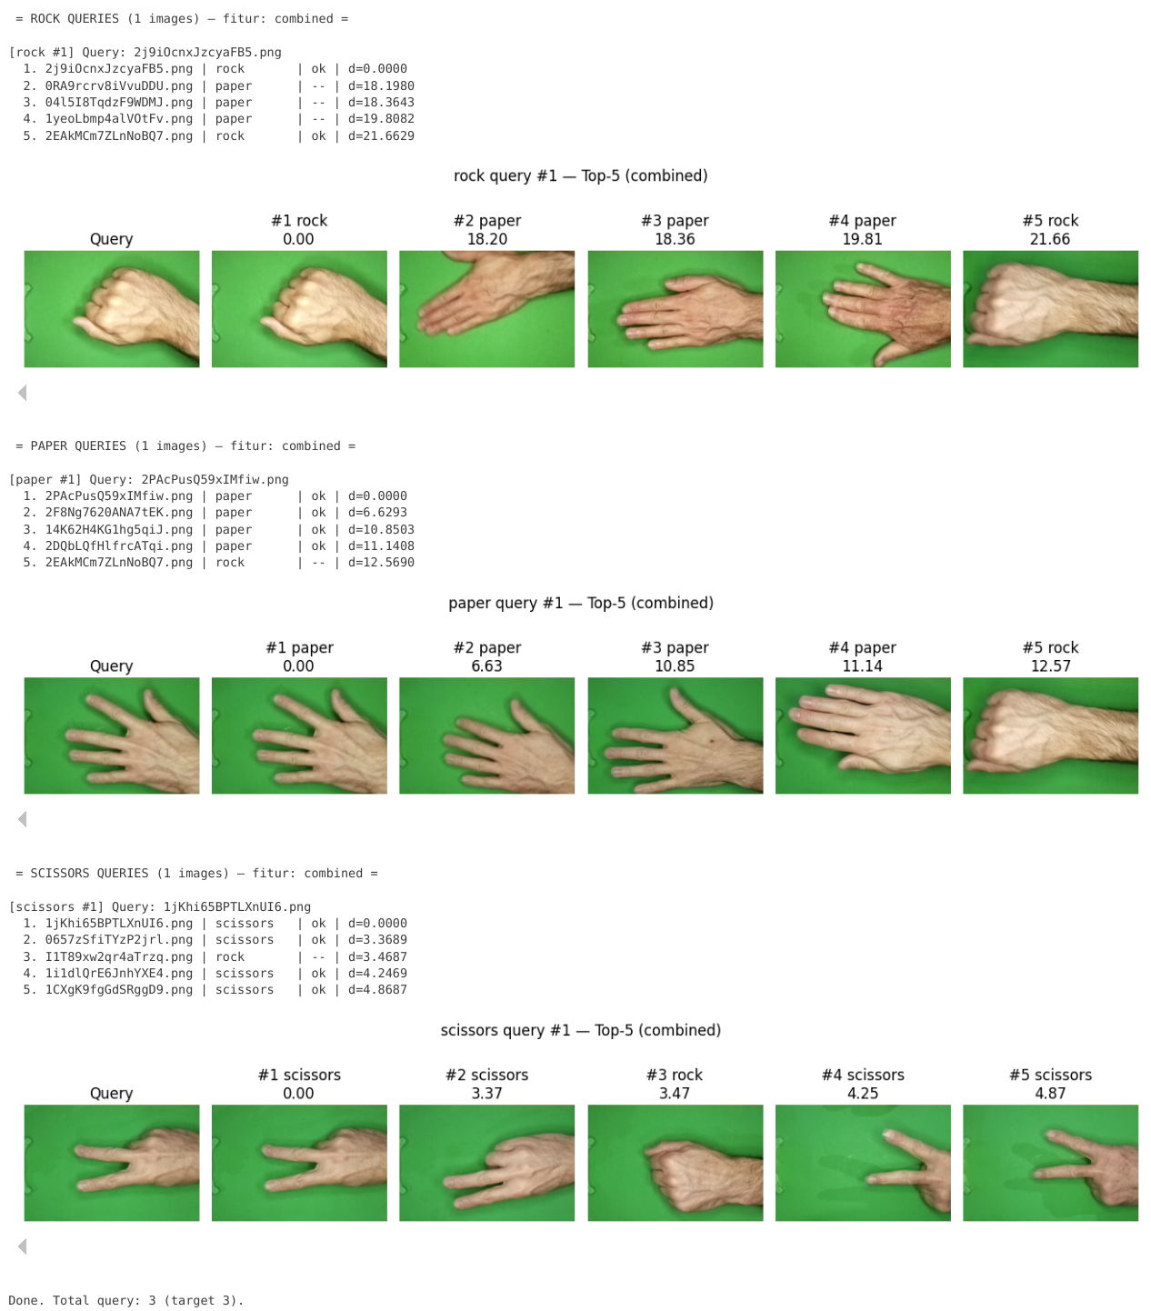

Tabel Precision@5
- Evaluasi masing-masing metode

import numpy as np
import matplotlib.pyplot as plt
from collections import defaultdict

def evaluate_p5_queries_per_class(num_per_class=5, class_order=("rock","paper","scissors"), seed=42):

if seed is not None:
random.seed(seed)

features = ["color", "glcm", "shape", "combined"]
items_by_class = defaultdict(list)
for path, cls in dataset:
items_by_class[cls].append(path)

scores = {f: defaultdict(list) for f in features}

for feat in features:
if feat == "color":
db_feats = db_color_s
q_fn = lambda q: sc_color.transform([extract_color_features(q)])[0]
elif feat == "glcm":
db_feats = db_tex_s
q_fn = lambda q: sc_tex.transform([extract_texture_features(q)])[0]
elif feat == "shape":
db_feats = db_shape_s
q_fn = lambda q: sc_shape.transform([extract_shape_features(q)])[0]
else:
db_feats = db_combined
q_fn = lambda q: np.concatenate([
WEIGHT_COLOR * sc_color.transform([extract_color_features(q)])[0],
WEIGHT_TEXTURE* sc_tex.transform([extract_texture_features(q)])[0],
WEIGHT_SHAPE * sc_shape.transform([extract_shape_features(q)])[0],
])

print(f"\nEvaluating feature: {feat.upper()}")

for cls in class_order:
pool = items_by_class.get(cls, [])
if not pool:
continue

picks = random.sample(pool, min(len(pool), num_per_class))
while len(picks) < num_per_class:
picks.append(random.choice(pool))

for p in picks:
q_img = imread_rgb(p)
q_feat = q_fn(q_img)
ranked = rank(db_feats, q_feat, TOP_K, USE_COSINE)
p5 = sum(db_meta[idx][1] == cls for idx, _ in ranked) / TOP_K
scores[feat][cls].append(p5)
print(f"{cls:10s} | {os.path.basename(p):20s} | P@5 = {p5:.2f}")

per_class_avg = {f: {cls: np.mean(vals) for cls, vals in d.items()} for f, d in scores.items()}
macro_avg = {f: np.mean(list(v.values())) for f, v in per_class_avg.items()}

print("\nAverage Precision@5 per Class:")
table = []
for cls in class_order:
row = [cls] + [f"{per_class_avg[f].get(cls, np.nan):.2f}" for f in features]
table.append(row)
print(pd.DataFrame(table, columns=["Class", "Color", "GLCM", "Shape", "Combined"]))
print("\nMacro Averages:", {k: f"{v:.3f}" for k, v in macro_avg.items()})

plt.figure(figsize=(8,5))
x = np.arange(len(class_order))
width = 0.18
offsets = [-1.5, -0.5, 0.5, 1.5]

for i, f in enumerate(features):
vals = [per_class_avg[f].get(c, 0) for c in class_order]
plt.bar(x + offsets[i]*width, vals, width, label=f"{f} (avg={macro_avg[f]:.2f})")

plt.xticks(x, class_order)
plt.ylim(0, 1.05)
plt.ylabel("Precision@5")
plt.title("Average P@5 per Class")
plt.legend()
plt.tight_layout()
plt.show()

return per_class_avg, macro_avg

per_class_avg, macro_avg = evaluate_p5_queries_per_class(num_per_class=5)
Output:

Evaluating feature: COLOR
rock | 2affjOmZChc9AXpR.png | P@5 = 0.60
rock | 02vG75hQW9Vp4oTl.png | P@5 = 0.60
rock | I1T89xw2qr4aTrzq.png | P@5 = 0.20
rock | 2f25VA1nfxiC86xj.png | P@5 = 0.40
rock | 19H63c0MWD56EWNq.png | P@5 = 0.60
paper | 0t08v9bAaA0mXGCQ.png | P@5 = 0.40
paper | 0eqArS2GgsBeqgSn.png | P@5 = 0.40
paper | 2IOsxsG8AaxntdJM.png | P@5 = 0.40
paper | 0cb6cVL8pkfi4wF6.png | P@5 = 0.20
paper | 2DQbLQfHlfrcATqi.png | P@5 = 0.80
scissors | 277q9TUTAsBAbTCj.png | P@5 = 0.40
scissors | 1VRzspyXpQ6A2rKy.png | P@5 = 0.60
scissors | 0CSaM2vL2cWX6Cay.png | P@5 = 0.60
scissors | 1WX9KKoq0nkWiTxI.png | P@5 = 0.40
scissors | 1L1n6plr7jlZGirw.png | P@5 = 0.80

Evaluating feature: GLCM
rock | 00nKV8oHuTGi20gq.png | P@5 = 0.60
rock | I1T89xw2qr4aTrzq.png | P@5 = 0.60
rock | 01dM3ewPIsnBICu1.png | P@5 = 0.80
rock | 0OEXfEooCXlljaEl.png | P@5 = 0.80
rock | 0P6uxM8Vr1DwySHe.png | P@5 = 0.20
paper | 1Tt9U9SzrOm98Xtw.png | P@5 = 0.80
paper | 1yKjzquSvl9ShK7K.png | P@5 = 0.60
paper | HU7Q4utMI0vHMxlh.png | P@5 = 0.80
paper | 1uoW7QcH2qAgCTxv.png | P@5 = 0.40
paper | 0RA9rcrv8iVvuDDU.png | P@5 = 0.40
scissors | 256MrhkDete6aQhP.png | P@5 = 0.80
scissors | 1xkTkvyzmavV7lQ5.png | P@5 = 0.20
scissors | 1VRzspyXpQ6A2rKy.png | P@5 = 0.60
scissors | 1L1n6plr7jlZGirw.png | P@5 = 0.40
scissors | 138Tx9KlEfheT3uB.png | P@5 = 0.60

Evaluating feature: SHAPE
rock | 1MOm36DHK0R8OfIC.png | P@5 = 0.40
rock | 1wk2Hl1Ih9guOwx6.png | P@5 = 0.40
rock | 19H63c0MWD56EWNq.png | P@5 = 0.00
rock | 2j9iOcnxJzcyaFB5.png | P@5 = 0.20
rock | I1T89xw2qr4aTrzq.png | P@5 = 0.40
paper | 2OCAZGNv2OEzgAwU.png | P@5 = 1.00
paper | 2PAcPusQ59xIMfiw.png | P@5 = 0.60
paper | 0Og76sl5CJhbxWWx.png | P@5 = 1.00
paper | 2F8Ng7620ANA7tEK.png | P@5 = 0.60
paper | 1fKclJk4eBWOQSR1.png | P@5 = 0.40
scissors | 1i1dlQrE6JnhYXE4.png | P@5 = 0.60
scissors | 17HZDUFSVPxcar99.png | P@5 = 0.80
scissors | 0Flw60Z2MAWWKn6S.png | P@5 = 0.60
scissors | 0zoQAmDFXehOZsAp.png | P@5 = 0.80
scissors | 2C9FEbBklwcVhF3W.png | P@5 = 0.60

Evaluating feature: COMBINED
rock | 1COBZEE1ALiJIivQ.png | P@5 = 0.60
rock | 02vG75hQW9Vp4oTl.png | P@5 = 0.60
rock | 01dM3ewPIsnBICu1.png | P@5 = 1.00
rock | 1e1VCnCEApnFh9Oo.png | P@5 = 0.60
rock | 1DxbXT3M2qiMjCmC.png | P@5 = 0.20
paper | 14K62H4KG1hg5qiJ.png | P@5 = 0.80
paper | 1yKjzquSvl9ShK7K.png | P@5 = 0.40
paper | 0Uomd0HvOB33m47I.png | P@5 = 0.40
paper | 2PAcPusQ59xIMfiw.png | P@5 = 0.80
paper | 04l5I8TqdzF9WDMJ.png | P@5 = 0.80
scissors | 277q9TUTAsBAbTCj.png | P@5 = 0.40
scissors | 1lEpWTJDphkm3HdC.png | P@5 = 0.20
scissors | 1VRzspyXpQ6A2rKy.png | P@5 = 0.60
scissors | 0ePX1wuCc3et7leL.png | P@5 = 0.60
scissors | 1jKhi65BPTLXnUI6.png | P@5 = 0.80

Average Precision@5 per Class:
Class Color GLCM Shape Combined
0 rock 0.48 0.60 0.28 0.60
1 paper 0.44 0.60 0.72 0.64
2 scissors 0.56 0.52 0.68 0.52

Macro Averages: {'color': '0.493', 'glcm': '0.573', 'shape': '0.560', 'combined': '0.587'}

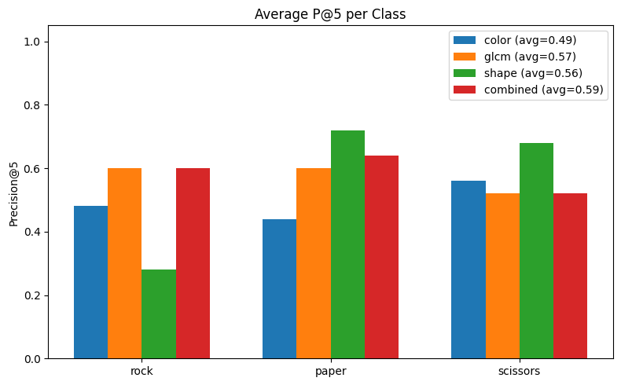

Kesimpulan

Pada tugas proyek ini, yaitu Content-Based Image Retrieval (CBIR) adalah sistem yang diimplementasikan menggunakan dataset dimana kelas dataset tersebut mengandung Rock, Paper, Scissors. Pada sistem ini hasil ekstraksi pada fitur secara langsung diambil dari image dari dataset tersebut tanpa ketergantungan label. Untuk dapat mengambil hasil data pada image kita mengambil data fitur ekstraksi yaitu:

- Fitur Ekstraksi Warna : HSV histogram (8 x 8 x 8) menggunakan statistik (mean, std, skew, kurtosis.
- Fitur Ekstraksi Tekstur (GLCM): Gray level Co-Occurrence Matrix (GLCM) metrics (contrast, correlation, energy, homogeneity)
- Fitur Ekstraksi Bentuk (Thresholding): memperoleh data dari contour/kontur terbesar setelah ambang batas otsu (area, perimeterm aspect, ratio, solidity, circularity)

Seluruh fitur di normalisasikan menggunakan StandardScaler, yang disimpan pada fitur database lalu digunakan untuk mengukur kesamaan Query menggunakan metric Cosine == True atau Euclidean == False. Sistem ini mengurutkan dan menampilkan 5 terbaik K == 5 gambar paling mirip untuk setiap query dan kinerja tersebut dievaluasikan menggunakan P@5 atau Precision@5.

Dengan mengintegrasikan fitur warna, tekstur, dan bentuk yang dibuat dengan hasil preprocessing dan fitur similarity, CBIR ini berhasil menunjukan pengambilan gambar yang serupa secara semantik dari kumpulan data multiclass secara akurat.

